Templates

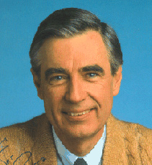
HELLO NEIGHBOR!

Tuesday, August 3 is the
National Neighborhood Night Out event.
It’s an opportunity to get to know your neighbor. Here in the Conservatory, at 7 pm, we are observing this chance to get to know the fine people who live on your street. Let’s have an “Ice Cream Social” to get acquainted. If you are game to help organize the get-together on your street, please contact _______ by email at ___________ or text ___________ at ____________.
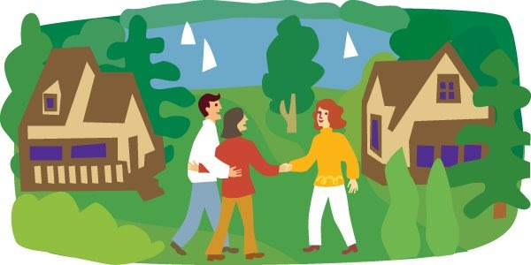

- - - - - - - - - - - - - - - - - - - - - - - - - - - - - - - - - - - - - - - - - - - - - - - -
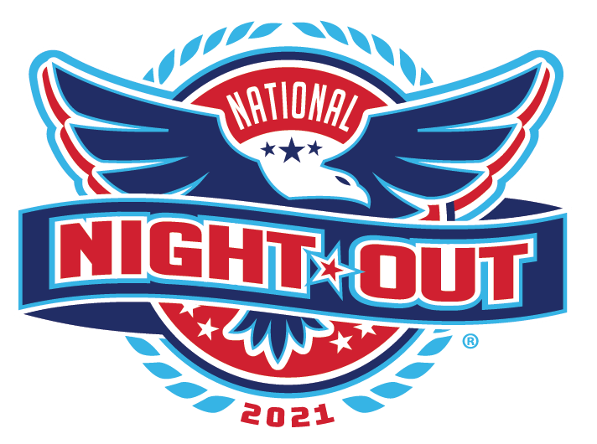
ON KILLARNEY WAY,
THERE’S SOME VERY FINE PEOPLE!
Tuesday, August 3, is National Neighborhood Night Out.
Meet your fine neighbors that evening for an Ice Cream Social beginning at 7 pm. Bring a spoon and a smile to get to know your next-door neighbors. You may gain a few calories, but you can also gain some new friends.
- - - - - - - - - - - - - - - - - - - - - - - - - - - - - - - - - - - - - - - - - - - - - - - -
BLOCK PARTY! YOU’RE INVITED!
On _______ evening, August ____ , you are invited to meet your neighbors on our block. Bring a spoon and a smile, and come outside to get acquainted with the other people who just happen to live on our street. Please RSVP to _____ if you would like to help coordinate the friendly get together.

